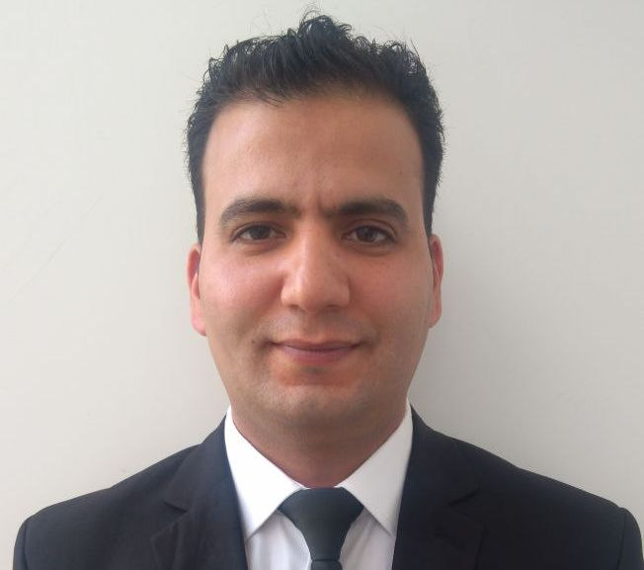

Looking For F&B Butler/Supervisor position:

MRABET KHALID
mrabet2950@gmail.com
Tél : +971 52.64.84.281
Brief: Hi , Im from morocco ,having worked in différent propriétés,at local and private accompanys,I'm now looking for a change.
Being Very disciplined,hard working, professional, and I'm looking to learn something new.

EDUCATION:
2007
2007 : Diploma of technician in hotel specialty restaurant, at the institute specialized in applied technology in hotel and tourism ISTAHT-AGADIR.
2004 : Bachelor's degree in experimental sciences.
2004

PROFESSIONAL EXPERIENCES:

From 04/01/2018 until present: Work as Back office suport at the Sofitel the palm,Dubai ;

- Submitting all documents on a daily basis and all theevents to DTCM(Department of tourism and commerce
Marketing).
- Daily use of Redberry system for verification of the passports of the guest and sending email to the government to make sure passports/ emirates ID are valid.
- Arranging Registration card in order and Filing guest’s receipt in the bucket properly.
- In charge of DTCM(Department of Tourism and Commerce Marketing) fixing mistakes on a daily basis and doing reconciliation reports of every month.
- Help Operator for translate (ARABIC & FRENCH) Guest and explain Facilities of the Hotel.

From 01/10/2016 To 31/08/2017: Work as a BULTER at the FOUNDATION HASSAN II in Agadir (HRM)
- To ensure that all requests from Guests are made possible and are followed up on.
From 07/11/2014 TO 19/09/2016 : Work as a Head waiter at the restaurant YACHT 33; AGADIR ATLAS
Hospitality.
- Catered events at customers' houses. Served food, attended to guests and broke down event at the end of the evening..
From 01/12/2013 To 01/11/2014 : Work as a Head waiter at the Restaurant La plancha du rocher in Agadir.
- Demonstrated ability to provide guests with genuine hospitality and to deliver
From 01/08/2012 To 30/11/2013 Work as Head waiter of the restaurant SAITOKAN (Japanese) in Agadir.

- Held responsibility of handling/serving all food and beverage

From 15/07/2018 To 01/08/2012 : Work as Head waiter in restaurant LES BLANCS-MARINA in Agadir; organization of tasks.
- Provided guests with an exceptional dining experience and quality service.

Training:
From 05/04/2007 To 05/05/2007 : Internship in restaurant service at Hotel LES ALMOHADES in Agadir
From De 01/03/2007 To 01/04/2007 : Internship at restaurant service at AL MASSIRA airport in Agadir
From 10/11/2007 To 10/12/2007 : Internship at restaurant service at Hotel SOFITEL in Agadir
From 23/12/2005 To 05/01/2006 : Internship at restaurant service at Hotel ATLANTIC PALACE in Agadir
From 15/07/2006 To 13/08/2006 : Internship as a bartender at Hotel ATLANTIC PALACE in Agadir.
Professional skills:
• Proficiency in catering and hospitality.
• Ease and good team spirit.
• Personnel management, service and procurement.
• Purchases, stock movements, cash.

LANGUAGES:
- Arabic : Maternal languages
- French : Good masters of listening, writing, and communication
- English : Good level of listening, writing, and communication
- Spanish : Basic

Reference:

Mr.Ahmed Shehta
Head butler
+971566970063.

